WCS Bookkeepers’ Blogs
Karen Widener, Technology Secretary/Bookkeeper
Hosted By:

Current Forum questions:
How do I Change /Retain font settings? (Options 1 & 2)

Solutions:

Method 1
To set and make sure that the style of the default font in Word 2010 or Word 2013 is retained or saved, follow these steps:
- If you do not have a document open, create a new document that is based on the Normal template. To do this, click File, click New, click Blank Document, and then click Create.
- In the Font group, click the Font flyout to open the font dialog box.

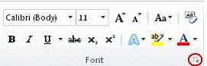
- Select the options that you want to apply to the default font, such as font style and font size. If you selected specific text, the properties of the selected text are set in the dialog box.
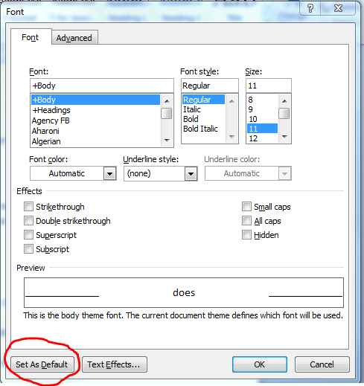
- Click Set As Default.
- Select All documents based on the Normal.dotm template?
- Click OK.

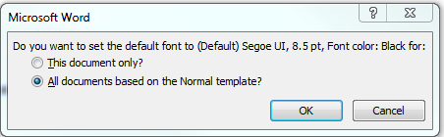
- This guarantees that every new document you open will use the font settings that you selected and set as the default. The default font applies to new documents that are based on the active template, usually Normal.dotm.

Method 2
To set and make sure that the style of the default font in Word 2013 is retained or saved, follow these steps:
- If you do not have a document open, create a new document that is based on the Normal template. To do this, click File, click New, click Blank Document, and then click Create.
- Click on the Design tab at the top and set all of the options that you want in your template.

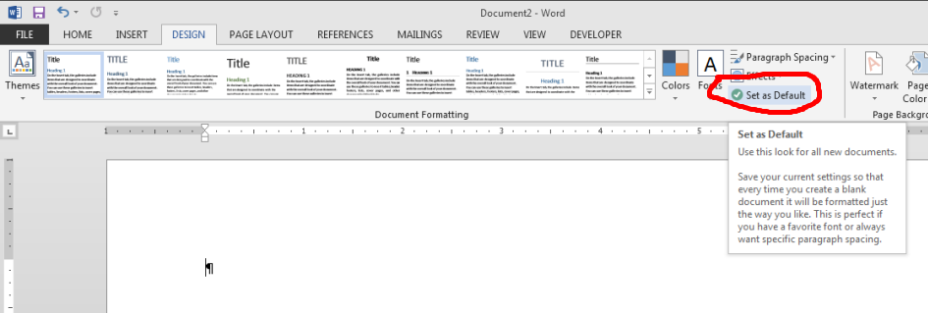
- Click Set as Default.
4. Click OK.

Additional Comments:

