WCS Bookkeepers’ Blogs
Karen Widener, Technology Secretary/Bookkeeper
Hosted By:

Current Forum questions/Topics:
I can’t get Excel to print all of the lines and rows in my spreadsheet!

Solutions:
Many of us use Excel and usually without too many problems. However, I had a co-worker to contact me regarding printing issues with Excel. The last line of her spreadsheet would not print. She was highlighting the entire area that she wanted to print but when doing a print preview the last line was not showing up.
The Solution:
- While in your spreadsheet, highlight the entire area that you want to print
- Go to Page Layout
- Click on Print Area
- Select Set Print Area
- Then go to the File tab and proceed through the printing steps. Once you click File then Print you will see all of the area that has been set for print.
Note: This process should work for most versions of Excel. Some of you may have a Menus tab next to the File tab in your toolbar area. If you have that menus tab, you can access the Set Print Area option from there as well.

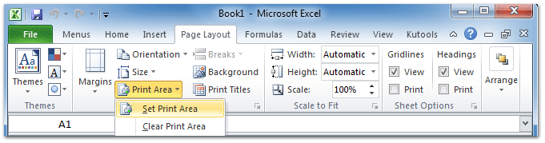

Additional Comments:

