WCS Bookkeepers’ Blogs
Karen Widener, Technology Secretary/Bookkeeper
Hosted By:

Current Forum questions:
How do I restore my Munis icon to my desktop?

Solutions:
Don’t panic ladies! Your Munis icon is not gone forever, although some days you may want it to be. To restore your Munis icon back to your desktop, follow these few simple steps:
- Open the Munis program
- Go to your favorites bar and click on the little star (red arrow)
- Click one of the headings (purple arrows) and drag it to your desktop. You will need dual monitors or you will need to have the Munis screen minimized in order to do this step.
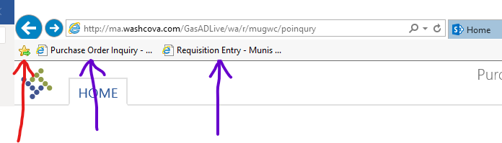
- Once you have moved the icon to your desktop, rename the icon to Munis

AdditionalComments:

