Copying Master Schedule in PowerScheduler for Load Only – PowerSource #8270

This article describes how to copy the master schedule in PowerScheduler for a Load-only scenario.
- Navigate to Start Page > PowerScheduler > Auto. Scheduler Setup and create a new scenario.
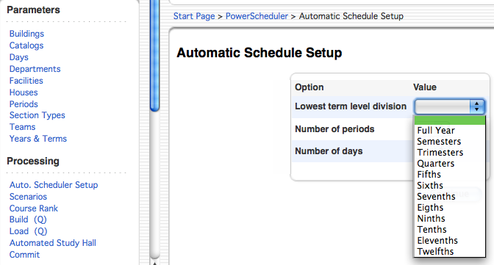
- Navigate to PowerScheduler > Functions > Set Schedule Year. The schedule year should be set to the upcoming school year for which you are creating a new schedule.
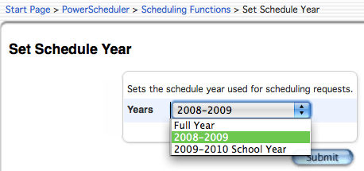
- Navigate to PowerScheduler > Scenarios and click on the name of the new scenario. Ensure that the scenario is "Active" and uses matching periods and days from the prior school year.
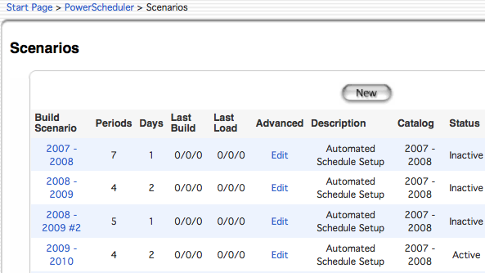

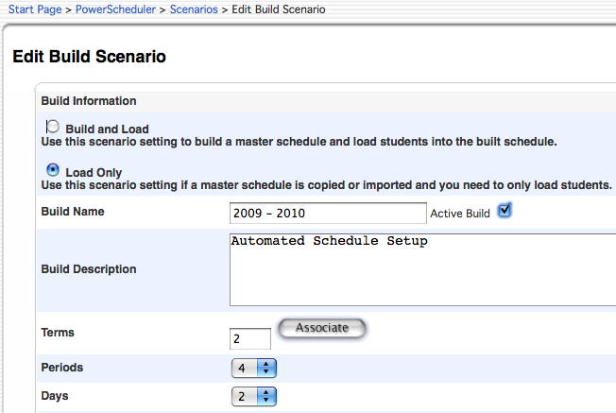

- Copy the Master Schedule from the previous school year at PowerScheduler > Functions > Copy Master Schedule.
