Exam Exemptions
In order for the “exempt” grade to show on the report card, you must use the “Exempt from Exams” comment for the student’s exam grade. Follow these simple steps.
- Open your gradebook.
- Click the “Scoresheet” tab.
- Change the “Reporting Term” to “E1”, “E2” or “E3”, whichever one is being exempt.
- For the student you want to mark exempt, double-click in the “(E1) Final Grade”, “(E2) Final Grade” or “(E3) Final Grade” column to bring up the score inspector. You can also right-click and choose “show score inspector”.

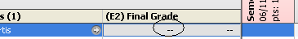

- Click the “Comment” tab. (Do NOT check the “Manual Override” option!)
- Double-click on #20, the “Exempt from Exams” comment. It will drop down to the box below. Click Close.
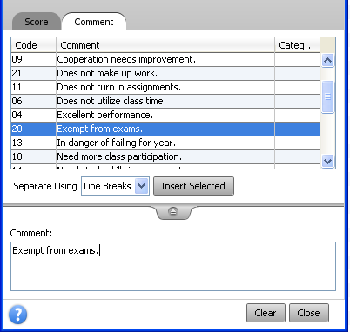

- It will show a very tiny blue “c” next to the student’s E2 or E3 grade to denote the comment. Repeat for all students who are exempt in this class.
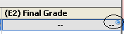

- Click on Save in the bottom right corner.

