How to Mass Enroll students in Courses

Summary

Use the Mass Enroll group function to enroll a group of students into the same course and section at the same time. The students must be enrolled on a date that is marked in session on the calendar, otherwise the will receive an error-"cannot create section enrollment record in database."

Details

To mass enroll a group of students follow these steps:
- Select a group of students on the Start Page.
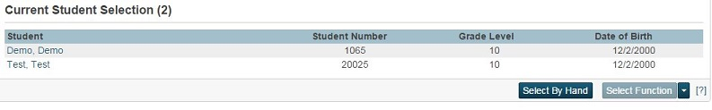
- From the functions drop-down menu, choose either Mass Enroll or Select Students by Hand. If Mass Enroll is select, skip to step 5.
- If using Select Students by Hand, choose either a group of students using the "Shift" key, or individual students using the "Command" key.
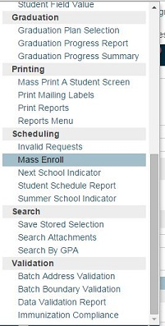
- Click on Functions and select Mass Enroll from the functions menu.
- Enroll the students in a section by either:
  - Choosing a Teacher and an Expression.
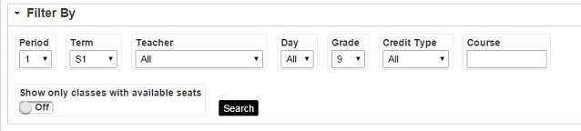
  - Entering the course.section. For example, if the course number is 12345 and the section number is 1, enter "12345.1" in the text field.
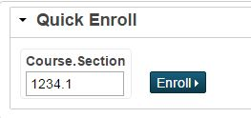
- Click the course name that you would like to enroll the selection into
- Notice that the Mass Enroll Preview appears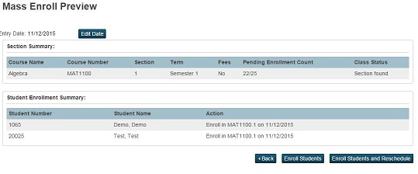
- Enter the enrollment date by clicking Edit Date . This is usually the first day of class. For example, if you are enrolling students into a Semester 2 course, the enrollment date will be the first day of the Semester 2 term.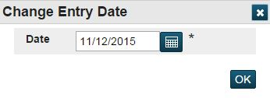
- Click Enroll to enroll student into this class for the first time or Enroll Students and Reschedule to Reschedule them for an existing class in that time block. Once you make a choice you will be redirected to the new class roster and should receive a confirmation message stating that the changes made have been saved.
Note: Users who do not have access privileges to the Modify Schedule student screen will not be able to use the Mass Enroll group function. This is a known issue and is described in article 7654.

