Adding Inclusion and Pull-Out Teacher as Additional Staff to Sections as Part of Master Schedule Collection

- Collect the following data before entering the additional staff record:
  - Inclusion teachers – The special education teacher who is not the lead teacher but works with students within the classroom most of the time.
  - Pull-Out teachers – The special education teacher who is not the lead teacher but pulls certain students out of the classroom to work with them.
  - Determine which classes they should be assigned to (teacher, class, period)
  - For Pull-Out teacher you will need the names of the individual students that they work with.

- To enter each instance of an additional teacher in the classroom go to PowerSchool and click on the Teacher Schedule link on the left under Functions.

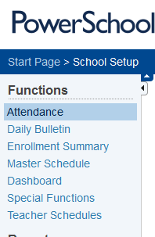

- Click on the name of the lead teacher of the first class to add the teacher to.

- Determine which class you want to work with first and click on the Sec # link.

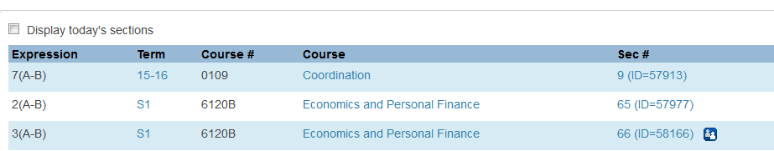

- Once in the Edit Section page scroll until you see a link that is titled Additional Staff Records and click on it. Note that this is different than adding a co-teacher.

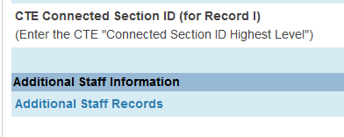

- Click on New.
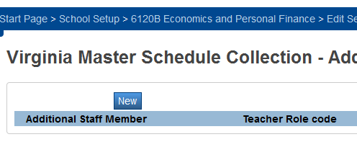

- From the Additional Staff Member drop down select the special education teacher who is either the Inclusion or Pull Out teacher.

- From the Teacher Role Code drop down select 2 for Inclusion or 4 for Pull-Out.

- If you selected 2 as the Teacher Role Code click on Submit to save your entry.

- If you selected 4 as the Teacher Role Code skip to the Additional Staff Member line and choose the student name or names that the Pull-Out teacher works with. To select more than one student you must hold down the Ctrl key on your keyboard.

- Click .

- If additional sections are added throughout the year please repeat the process.

