Adding Inclusion, Pull-Out, and Co/Team Teachers as Additional Staff to Sections as Part of Master Schedule Collection

- Collect the following data before entering the additional staff records:
  - Inclusion teachers – The special education teacher who is not the lead teacher but works with students within the classroom an ample amount of time.
  - Pull-Out teachers – The special education teacher who is not the lead teacher but pulls certain students out of the classroom to work with them.
  - Determine which classes they should be assigned to (teacher, class, period)
  - If a teacher is a Pull-Out teacher you will need the names of the individual students that they work with.
  - Co/Team teachers who are not special education teachers. Examples of this would be P.E. teachers who are not assigned their own sections of a class.
NOTE: A teacher cannot be added to the same section in the Additional Staff Record page more than once.

- To enter each instance of an additional teacher in the go to PowerSchool and click on the Teacher Schedule link on the left under Functions.

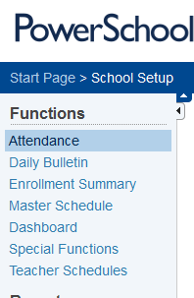

- Click on the name of the lead teacher of the first class to add the teacher to.

- Determine which class you want to work with first and click on the Sec # link.

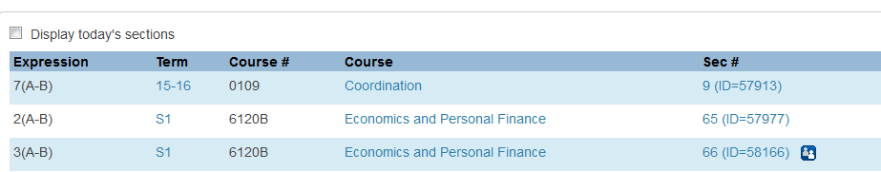

- Once in the Edit Section page scroll until you see a link that is titled Additional Staff Records and click on it. NOTE: This is different than adding a co-teacher near the top of the Edit Sections page.

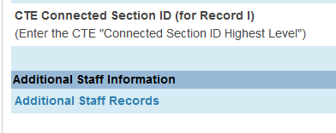

- Click on New.
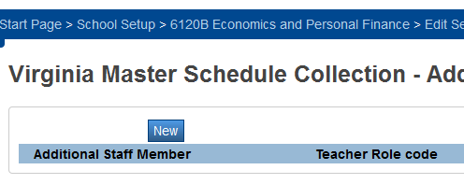

- From the Additional Staff Member drop down select the teacher who is either a co-teacher, Inclusion teacher, or Pull Out teacher.

- From the Teacher Role Code drop down select:

  - 1 for the non-Special Ed. teacher that is the co/team teacher (go to step 9)
  - 2 for Inclusion teachers (go to step 9)
  - 4 for Pull-Out teachers (go to step 10)

- If you selected 1 or 2 as the Teacher Role Code do not mark any other fields and click to save your entry and go to next sections.

- If you selected 4 as the Teacher Role Code skip to Additional Staff Member for: and choose the student(s) that the Pull-Out teacher works with. To select more than one student you must hold down the Ctrl key on your keyboard.

- Click .

- If additional sections are added throughout the year please repeat the process.

