WASHINGTON COUNTY SCHOOLS
DISCIPLINE LOG ENTRIES

ENTERING A DISCIPLINE RELATED LOG ENTRY

- On the Start Page, enter the student’s last name, first name in the search box.
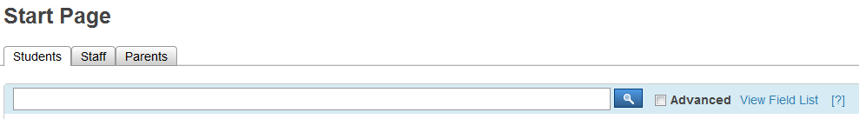

- From the Student menu on the left, click Log Entries in the Administration section.

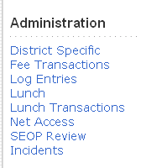

- All current log entries will be displayed on the screen. Click New to start a new log and complete the following. Please note the required fields.

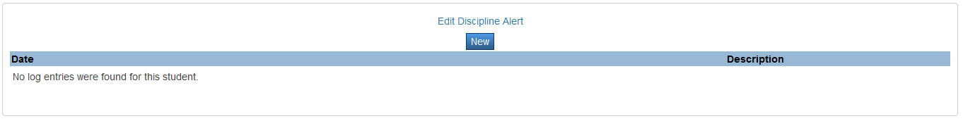

- Date & Time (REQUIRED): Enter the date and time of the incident.

- Referred By (REQUIRED): Auto generated with person’s name creating the incident record. CHANGE to name of teacher/staff member who referred the incident (LastName, FirstInitial).

- Log Type (REQUIRED): Choose the appropriate log type (below) from the pop-up menu.

- For Attendance related referrals choose Attendance and continue through step 12.
- For Minor Incidents that DO NOT result in an out of school suspension choose Discipline – Local and continue through step 12.
- For all other Discipline referrals choose Discipline and continue to the end of these instructions.

- Subtype: Enter the subtype as follows.

      - If the Log Type is Attendance, then select a subtype.
      - If the Log Type is Discipline – Local, then select a subtype.
      - If the Log Type is Discipline, only select a subtype if using HP1 (Horse Play) or SV4 (Dress Code Violation).

- Consequence: Enter the consequence as follows.

      - If the Log Type is Attendance, then select a consequence.
      - If the Log Type is Discipline – Local, then select a consequence.
      - If the Log Type is Discipline, only select a consequence if using HP1 (Horse Play) or SV4 (Dress Code Violation).

- Title (REQUIRED): Enter the code description of the discipline entry. This field is displayed on the student Log Entries page.

- Log Entry Text (REQUIRED): Enter information as related to each particular incident. The Log Entry Text is displayed on the student Log Entries page. There is no limit to the length of the entry. Note: This information goes in the student's permanent record.

- Incident Date (MM/DD/YYYY) (REQUIRED):

- Author: Enter the name of the person entering the incident (LastName, FirstInitial).

- Stop if Log Type chosen was Attendance or Discipline – Local.

- VIRGINIA STATE INFORMATION (REQUIRED for all major incidents and minor incidents that result in an out of school suspension.

    - Enrolled Division (REQUIRED): Begin typing Washington County Schools or enter 094 as the enrolled division for all students enrolled in Washington County Schools.

        - A dropdown will appear for you to choose Washington County Schools.

    - Enrolled School (REQUIRED): Begin typing the school name or enter the state assigned school number of the school where the student is officially enrolled.

      - A dropdown will appear for you to choose the appropriate school.

    - Incident Division (REQUIRED): Begin typing Washington County Schools or enter 094 as the incident division for all discipline incidents that occur within the Washington County School System.

      - A dropdown will appear for you to choose Washington County Schools.
      - If the incident occurred in another division, begin typing the school division where the incident occurred then choose that school division.

    - Incident School (REQUIRED): Begin typing the school name or enter the state assigned school number of the incident school for all students enrolled in your school.

      - A dropdown will appear for you to choose Washington County Schools.
      - If the incident occurred in another school, begin typing the school name where the incident occurred then choose that school division.

    - Incident Date (mm/dd/yyyy) (REQUIRED): Enter the date the incident occurred.

    - Incident Number (REQUIRED): The incident number will be auto-generated. When more than one student is involved in an offense this number must be the same for all discipline log entries.

    - Primary Offense Code (REQUIRED): Enter the code that identifies the primary offense.

      - DO NOT click on the (Codes) hyperlink. Use the WCS Discipline Data Form for current state offense codes.

    - Offense Code 2: If applicable, enter the code that identifies a secondary offense related to the same incident.

      - Enter the secondary offense code into this field when there are multiple offenses in the same incident.
      - DO NOT click on the (Codes) hyperlink. Use the WCS Discipline Data Form for current state offense codes.

    - Offense Code 3: If applicable, enter the code that identifies a third offense related to the same incident.

      - Enter the third offense code into this field when there are multiple offenses in the same incident.
      - DO NOT click on the (Codes) hyperlink. Use the WCS Discipline Data Form for current state offense codes.

    - # Firearms Confiscated: Enter the number of firearms confiscated in relation to a weapons offense.

  - Required if weapons offense code is used.

- # Non-Firearms Confiscated: Enter the number of non-firearms confiscated in relation to a weapons offense.

- Required if weapons offense code is used.

- Final Division/Sanction Code (REQUIRED): From the pop-up menu enter the code that identifies the discipline sanction for the incident.

- # Days Suspended: Enter the number of days the students involved in the incident were suspended.

  - Required for codes 01 (IEP students only), 02, 03, and 04
  - Applies to full day suspensions only.

- # Victims: If applicable, enter the number of victims involved in the incident.

  - Required for Assault/Battery, Extortion, Homicide, Kidnapping, Robbery, Sexual Offenses, Stalking, Threats, and Theft.

- Alternative Placement: Select Yes if the student was placed in an alternative education program as a consequence of the incident. The default is No.

- Permanent Expulsion: Select Yes if the student was permanently expelled from the school or expelled for 365 days as a consequence of the incident. The default is No.

- Time Incident Took Place (REQUIRED): Enter the code that identifies the time of day that the incident took place. NOTE: This field does not default to a particular code, you MUST select one.

- Reported To Law Enforcement: Select Yes if this incident was reported to law enforcement personnel. The default is No.
- Required for all codes highlighted in yellow on Discipline Data Form.

- SPED Students Only – IEP Permanent Change in Placement: Select Yes if student was placed in an alternative education program as a consequence of the incident. The default is No.

- CRDC FIELDS (only fill out if state reported incident meets the following criteria).
SCH-17/SCH-18: Discipline of Students
- Expulsions
- Expulsions under zero-tolerance policies
- School-Related Arrest
SCH-30. Reported Allegations of Harassment or Bullying
  - This incident had an allegation of harassment or bullying on the basis of sex
  - This incident had an allegation of harassment or bullying on the basis of race, color or
national origin
  - This incident had an allegation of harassment or bullying on the basis of disability
SCH-32. Students Disciplined for Harassment or Bullying
    - This incident had students disciplined for engaging in harassment or bullying on
    - the basis of sex

    - This incident had students disciplined for engaging in harassment or bullying on
    - the basis of race, color or national origin
    - This incident had students disciplined for engaging in harassment or bullying on
    - the basis of disability
SCH-34/SCH-35. Students Subjected to Restraint or Seclusion
    - Student was subject to mechanical restraint
    - Student was subjected to physical restraint
    - Student was subjected to seclusion

Editing a Discipline Log Entry

- On the Start Page, enter the student’s last name, first name in the search box.

- From the Student menu on the left, click Log Entries in the Administration section.

3. All current log entries will be displayed on the screen. Click on the date of the Disciple log entry that needs editing and edit applicable fields.

