6553Correcting SBAR Errors

To look up an Incident by Local Event ID:

- PowerSchool start screen > Incident Management on the left menu
- Click the dropdown arrow on the blue bar under Create Incident
- A search bar will appear. Enter the Event ID #. Click Apply or Enter.
UPDATES TO THIS PAGE ARE IN RED
Each Incident Tells a Story | Required Fields
Components of an Incident.  - Offender - Who did it?  - Behavior -What did they do?  - Actions Required - What did Administration do?  - More Details  - Is a Support, Victim, or Weapon involved?  - When and where did the incident occur? | The following fields are required for each incident:  - Title  - Incident Type – VA State Reporting^  - Incident Date  - Time Frame  - Location  - Behavior  - Actions – all Behaviors require a Behavioral Intervention and Disciplinary Sanction. Instructional Support codes are conditional (ex. - if a student is suspended, an IS code is required)  - Attributes (victims) – conditional based upon the action  - Objects – conditional based upon the Behavior Code  *Connect Behavior to the Offender  *Connect all Actions to the Behavior
Error Message | How to correct the error
Event Location- Must be a valid code from list of Location of Events | Cannot be blank/null. Select appropriate location from the Location dropdown.
Disciplinary Sanction Code- Invalid Disciplinary Sanction Code- must be a valid code from Disciplinary Sanction Code list.  REQUIRED even if “NONE”  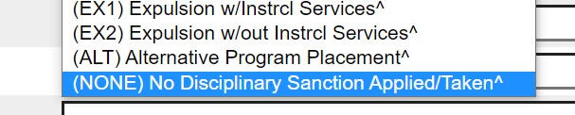  Disciplinary Sanction Code (con’t.)  Note: If you can’t drag and drop Elements, DELETE it by clicking on the subtract icon, click on Submit Incident and re-create it by clicking on the green plus sign. It seems to get “stuck” sometimes and won’t move and you run into that gray box. | Must be a valid code.  If no Disciplinary Sanction Code is linked to Behavior select one of NONE and link it to the Behavior.  If it’s there it may not be placed properly (indented) under the Behavior. The Sanction code needs to be carefully “dragged and dropped” ONTO the Behavior Code and not the student. (If not using Detailed Incident entry)  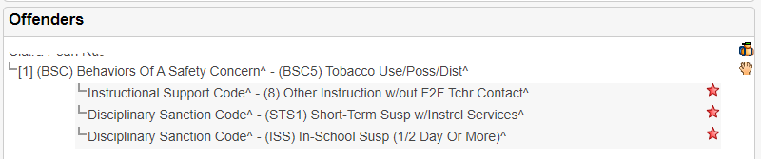  Discipline Sanction Codes STS2, LTS2, and EX2 are no longer valid. Out-of-school suspensions must include instruction and must have an Instructional Support Code. Replace these codes with appropriate code with the appropriate code that includes instructional support  If Behavior Code is BAP4, BAP5, or BSO4, Disciplinary Sanction Code cannot be STS1, STS2, or ISS
Instructional Support Code - If Disciplinary Sanction is STS1, LTS1 or EX1, then Instructional Support Services is required. | Guidance for Instructional Support Code  - Must be numeric  - Must be one character  - Cannot be blank if Disciplinary Sanction Code is STS1, LTS1, or EX1  If suspended - what instructional support are they getting? - Go to Incident Elements > Add Action > Instructional Support Code > pick from the dropdown
Missing C & D Records  *Additional Error related to C & D Records for students who have moved to another school, WCCTEC, homebound, withdrawn, etc.  Record B (Line 10): Local Event ID (1502)- An Event ID reported in the B Record is missing from the C Record.  No C or D records are being created for them. | The Student Behavior and Administrative Response information is incomplete OR  There are no Incident Elements in the Offenders field OR  There are missing required elements OR  The Elements are not placed properly meaning they are not “indented” under the Behavior. Drag and drop it over the Behavior.
Local Event Code/Behavior Code - Missing an E Record for a Behavior Code that requires a victim count | A behavior code that DOES REQUIRE a victim count must have one so the E record can be generated.  What is an E record? E records report the Victim on the SBAR generated at the central office.
Total Victim Count  If the Behavior code requires a victim count, the sum of Student Victims, Staff Victims, Other Adult Victims, and Other/Unknown Victims must be greater than 0 | If the behavior requires a victim count go to Incident Elements, hit “+”, then “add Attribute”, then select appropriate category and number.
Student Victims Count - Invalid Student Victims - Blank or valid number if victim count is required for the behavior code. | Make sure the behavior code requires a victim count. Remove the Victim attribute if it doesn’t.
Days Sanctioned  Where is this?  Click on the pencil next to Disciplinary Sanction. Scroll down to view the Duration Code, Assigned Duration, and Actual Duration. Include totals in both fields (when applicable).  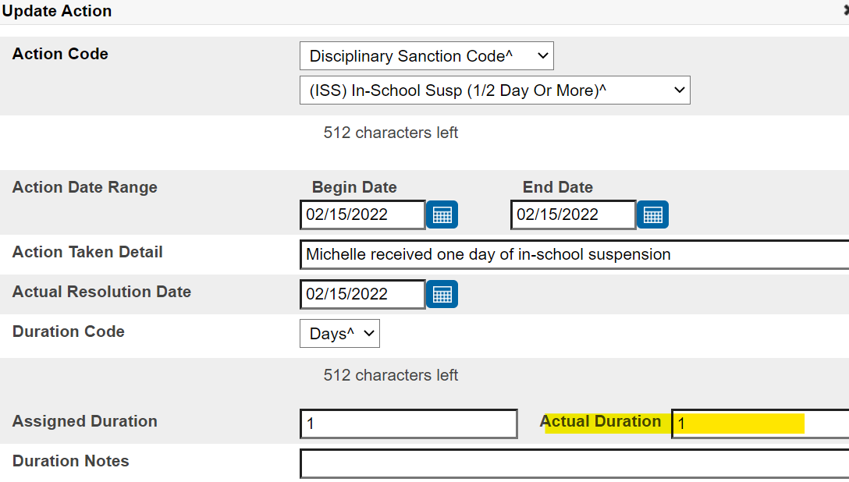  - Days Sanctioned must be blank or number between 1 and 365, or .25, .50, .75  - Days Sanctioned Inconsistent with Disciplinary Sanction Code  - Days Sanctioned must be null if Disciplinary Sanction Code is “NONE”. | - Must be blank, .25, .50, .75 or whole number between 1 and 365. Cannot be a zero.  - Must be > 0 if Disciplinary Sanction code is not NONE  - If Disciplinary Sanction Code is STS1 or STS2, then Days Sanctioned must be <11  - If Disciplinary Sanction Code is LTS1 or LTS2, then Days Sanctioned must be >10 and <=45 UNLESS Aggravating Circumstances Flag is Y.  - If Days Sanctioned is >45 for grades 4-12, then the Aggravating Circumstances Flag must be Y.  - If Days Sanctioned is >3 for grades PK-3, then the Aggravating Circumstances Flag must be Y.  - Remove Duration Code and blank out Assigned and Actual Duration
Event Time - Invalid Event Time - Must be a valid code from list of Time of Events  Required Field. Enter a valid entry in the Time Frame dropdown. | - Must be valid code  - Cannot be blank  1 = During the school day  2 = During a school-sponsored activity  3 = Not during school or activities  4 = In transit on the way to or from school
Event Location- Invalid Event Location - Must be a valid code from list of Location of Events  Required Field. Enter a valid entry in the Location dropdown. | - Must be valid code  - Cannot be blank  1 = Classroom  2 = Interior common area of school building  3 = Exterior area of school building  4 = On school bus or other student transportation  5 = At another school in the division  6 = Off-campus at a school sponsored event  7 = Off campus/other location including social media
Event School - Invalid Event Division/School - Must be a valid institution within the Event Division  Division number and School number should be enter in Location Comment when using Location Code 5-7 | - Must be valid code  - Refer to the list of Divisions/Schools posted at: (WIP)  - Must be in district if using Location Code 5  - Must be outside of WCS if using Location Code 6-7
Multiple D records – Behavior Code, Local Event ID, STI, etc. must be unique in the D Record. | Cannot have duplicate actions. i.e., 2 Disciplinary Sanction Codes.
Local Event ID/STI/Behavior Code – Combination of Local Event ID, STI and Behavior Code must be in C record | All behaviors must have an action. Add a Disciplinary Sanction Code. If there was no sanction add one of NONE.
Behavior Code – Invalid Behavior Code | Cannot be blank. Should be a valid Behavior Code
Charges Filed Flag/Behavior Code - Notified of Charges Filed Flag must be N if Behavior Code is not BESO18 | Remove Charges Filed Flag – Only to be used if an offense was a crime in the community that is required to be disclosed to the school division superintendent.
Conviction Flag - Notified of Conviction Flag Cannot be Y if Notified of Charges Filed Flag is N | Notified of Conviction Flag Cannot be Y if Notified of Charges Filed Flag is N
Invalid Hours Sanctioned - Hours Sanctioned cannot be reported for Disciplinary Sanction Codes STS1, SBP, LTS1, EX1, EX2, or ALT Disciplinary Sanction Codes | If DSC is STS1, SBP, LTS1, EX1, EX2, or ALT you must use a duration code of Days.
(NEW) Invalid Alternate Placement Educational Agency - Must be valid value if Disciplinary Sanction is "ALT" | Only used when a student is sent to a facility outside of WCS. If PASS or BRIDGE use another DSC that fits, then add an Instructional Support Code of 4.
(NEW) Hours Sanctioned - Hours Sanctioned cannot be reported for Disciplinary Sanction Codes STS1, SBP, LTS1, EX1, EX2, or ALT | Can only use a Duration Code of Days Sanctioned for those codes.

