PK, Aug 1st, 8am
- Make wiki pages
- Send email reminder to ITRTs and Jennifer
- Hand out scrap paper for FAQ posts
- Clear grades on test server
- MOVED report to Prod & Test
- Add more letters to Spelling Standards (only have Oo currently)
- P.SP.03 is a comment and not + -
- Show sample report card with teacher notes in Q1-Q4
- Remove standards from Homeroom
- Add tasks from ITRT training session
- Conference requested Y/N = checked or unchecked, +-
- Remove INC
- Remove grade for Report Card Comment
- Keep P.LIT.01 and 02 in the Homeroom but clear all the other standards (or move to other classes)
- P.SP.03 needs +-
- Show how to run the report cards from PTPro (Apps – not Reports)
- Determine the max length for recording the report card comment
- Determine and Compare the max length for printing out the report card comment

TEST QUESTIONS – which comment will appear on the report card?
AT THE END, challenge everyone to use their personal devices to login to PTPro
Amanda has new teacher orientation in the morning but will join us about 11am
Keep the teachers at least until noon

KG, Aug 4th 2pm
- Send email reminder to ITRTs and Jennifer
- Jrhea – present changes from PTG to PTPro
- Migration from PTG to PTPro
- Lokes – present how to record the standards in PTPro
AT THE END, challenge everyone to use their personal devices to login to PTPro

2017 PowerTeacher Pro Standards Training for PK or KG Progress Report Card at WCS
- Navigate to http://ps-custom.wcs.k12.va.us/teachers. We are using the test server for practice so nothing will change the live environment.
- Select a PreSchool teacher at your school and login with the email account and “test” as the password
- The Welcome to PTPro is displayed during first login
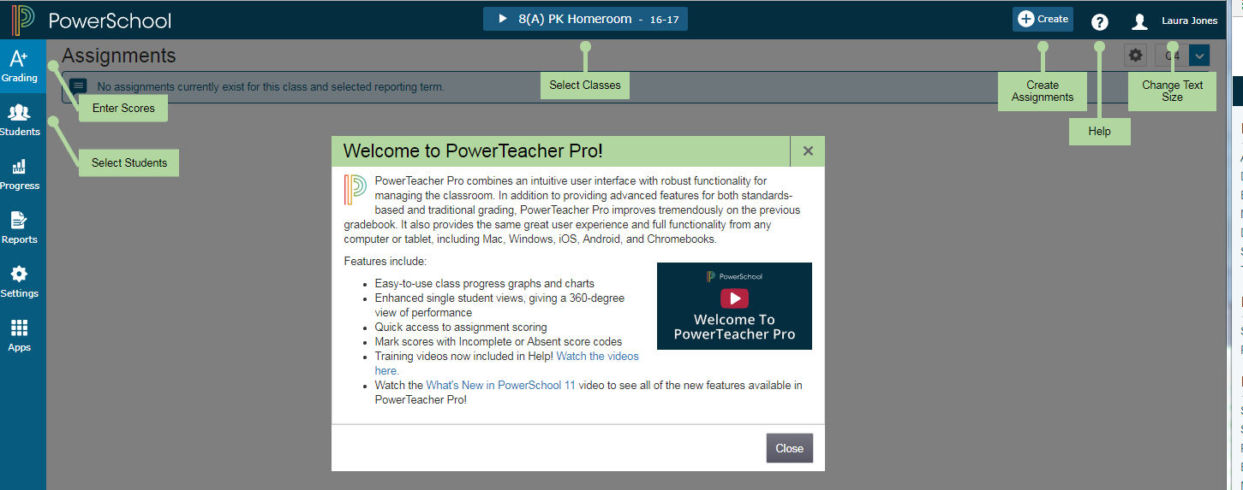
- Point out the areas and end with the Help icon
- Click on the Red Arrow to start the training video for 1-12 grades (not PK or KG), able to show video next to application?? – Many only needed for 1st-12th grades
  - Create new Assignment
  - Add all classes that need the new assignment
  - Describe categories
  - Description can be seen by parents and students
  - PK teachers need to see the Standards
  - Save, then duplicate if repeating assignment
  - Save and Close if finished

- To choose between classes, select the desired class in the dropdown list in the top middle of the screen.
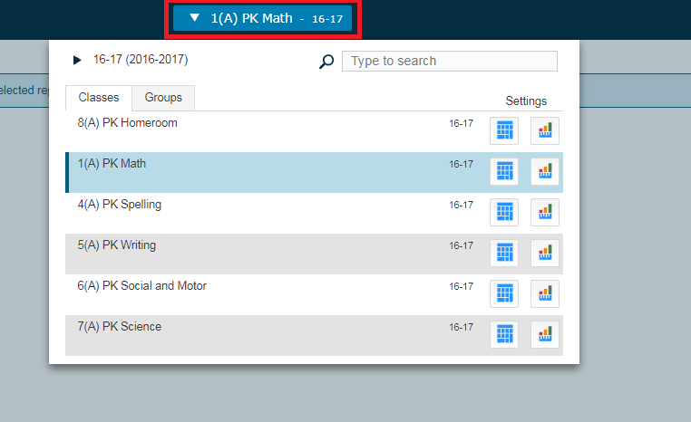

Now to explain the navigation icons along the left side of PowerTeacher Pro:
- GRADING
  - To see the students listed with the standards, select Grading on the top left then under Grades, click Standards.
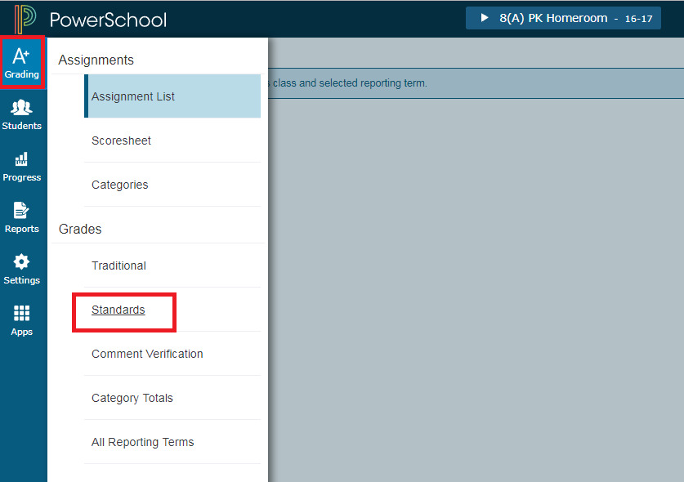
  - A list of students will appear with the standard numbers as the titles of the columns.
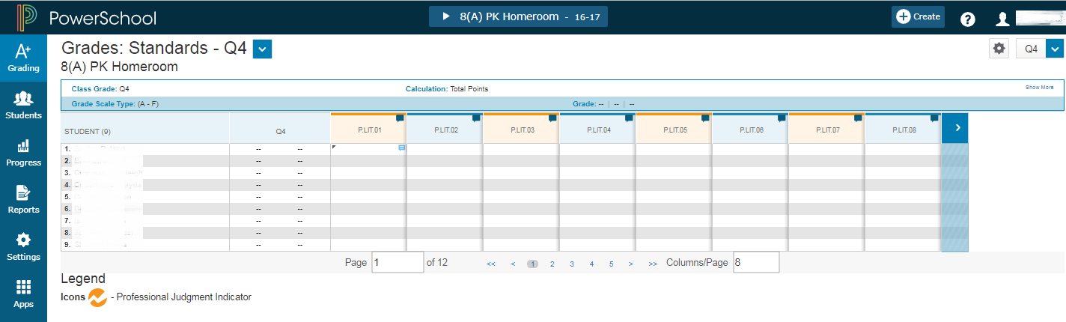

  - Keep a close eye on the top right corner that defines the grading term, Q1, Q2, Q3, Q4, or Y1. This will determine where your mark will display on the Preschool Progress Report Card. Choose the current term unless you would like to only show one grade for the Letters and Sounds. In this case, select the Y1 term to reduce redundancy.
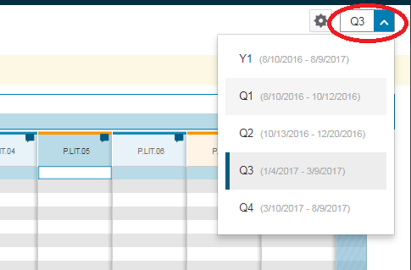
  - To see the Standard title, hover over the standard name at the top of each column
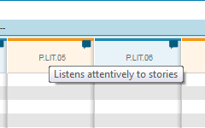
  - To record a grade for each standard, select the cell for the specific student under a column heading. Type or click on the available letter grades for the standard.
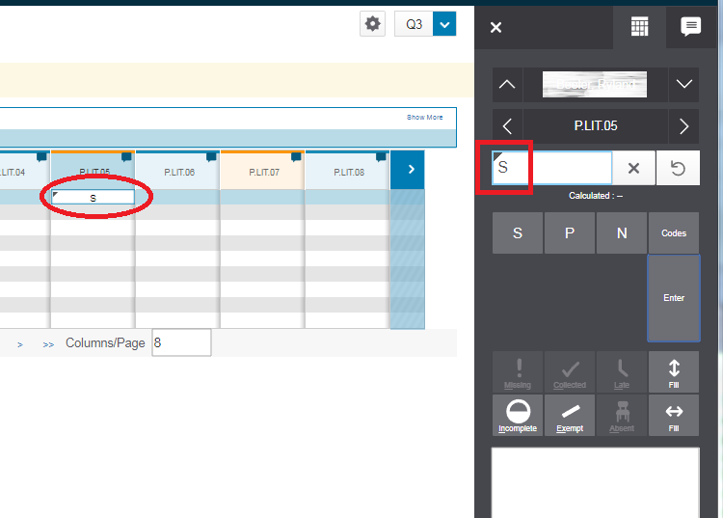
  - To copy the recorded grade to other students or to other standards, simply click on the Fill button on the lower right of the keypad after inserting the grade.
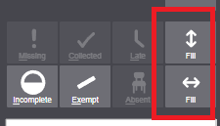
  - The grades will fill the blank cells but will not replace existing grades marked for the standards.
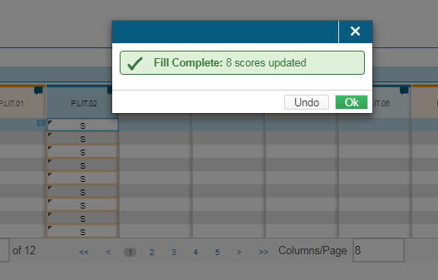

PROGRESS REPORT CARD COMMENT
  - To record a comment for the parents to display on the printed Preschool Progress Report Card, type the text in the P.LIT.01 column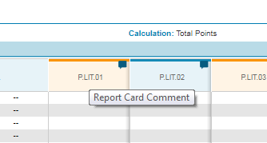

  - Type the comment in the lower right corner, not as a grade for the standard. This comment is visible to the parents.
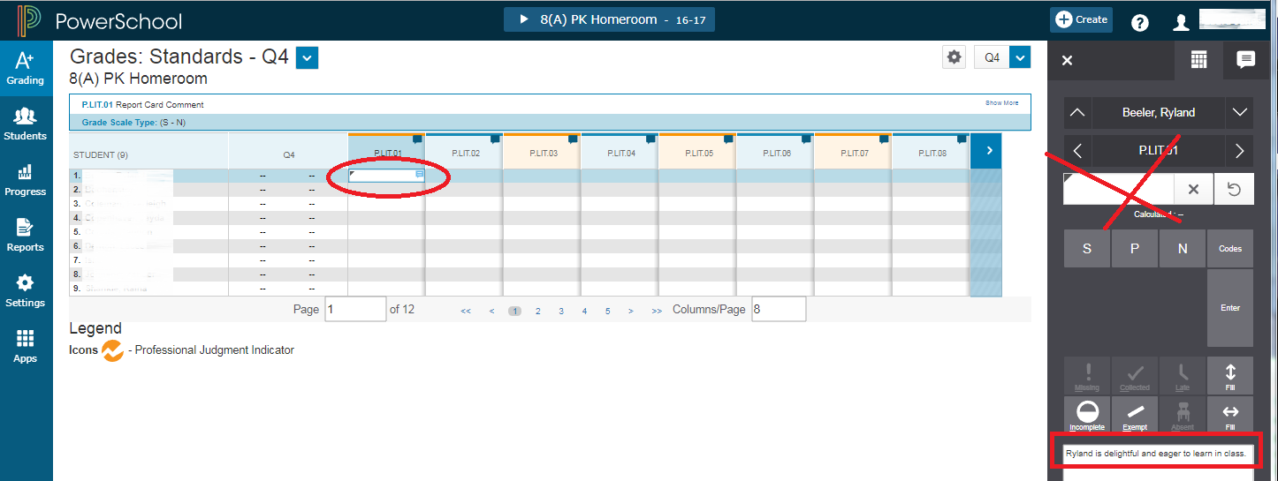
  - Once the comment has been recorded, a small text icon appears in the top right corner of the cell.
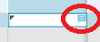

- STUDENTS
  - To see all of the standards listed for a single student, click on the Students icon.
  - Select the Standards Progress view then select the desired student’s name.
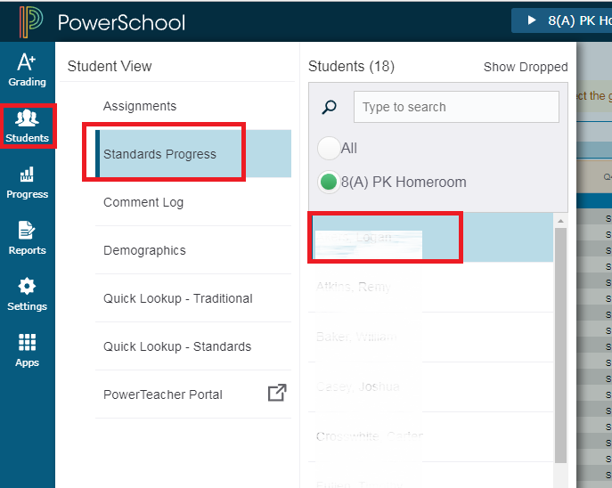

h. To add scores with this view, simply click on the cell and type or use the keypad on the right side.
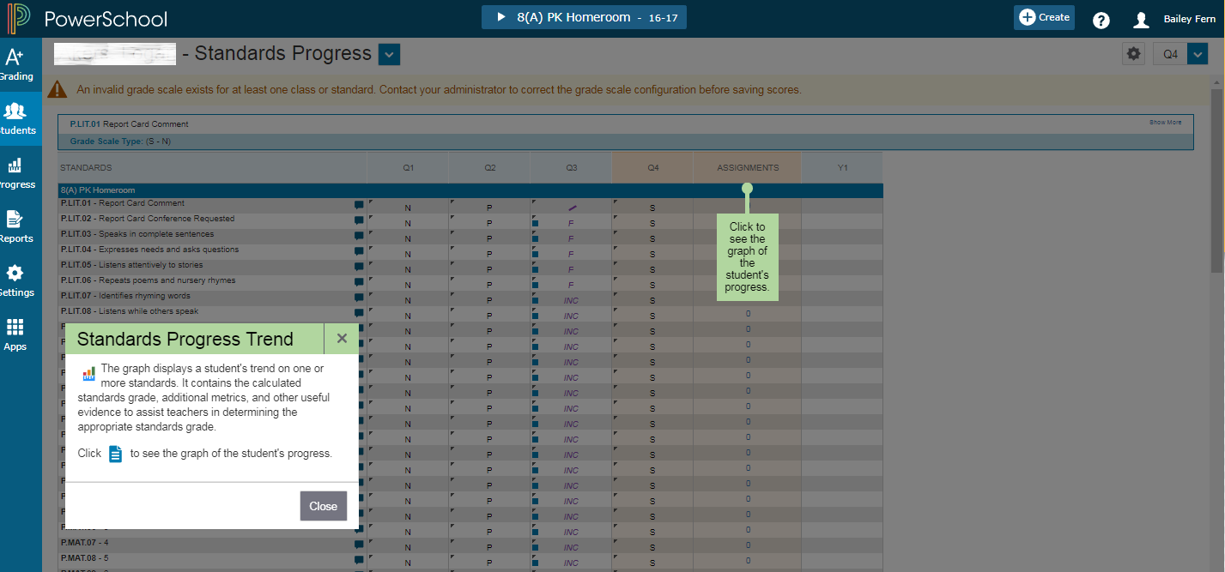
- PROGRESS
  - To see the students’ progress with the Standards, click the Progress icon then select Standards.
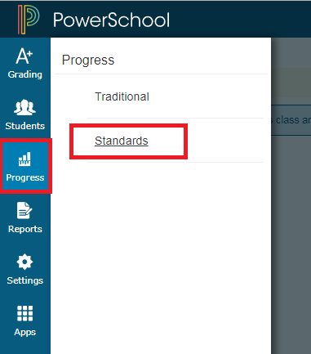
  - The list of standards is shown for the class to determine which need more attention.
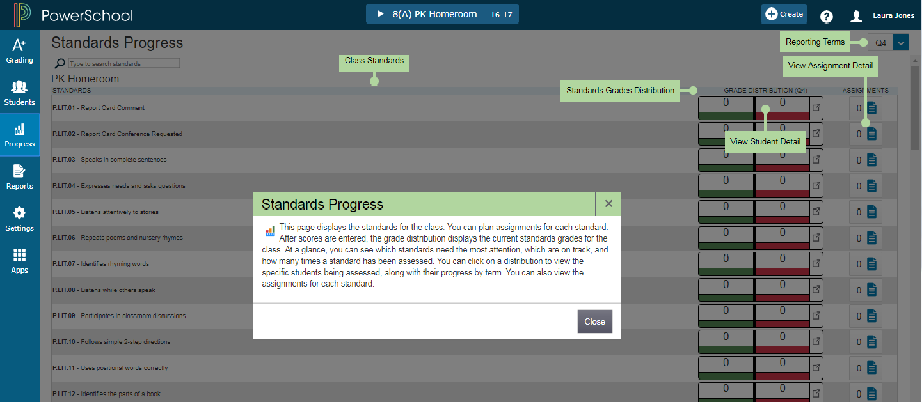
  - The Standard Grades Distribution screen shows the trends in the current term compared to the previous term. The red and green arrows indicate which have improved and which need more attention.
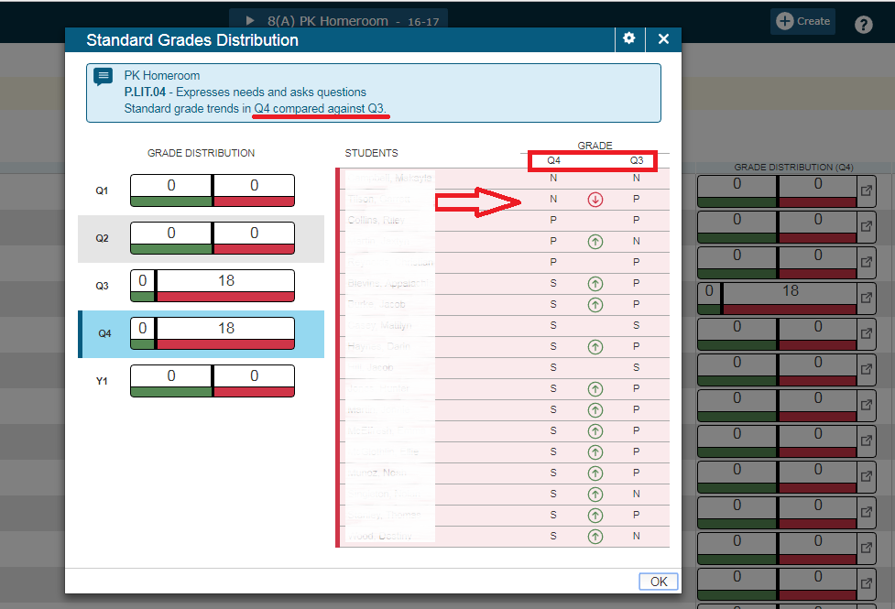
- REPORTS
  - To run a report for your students, click the Reports icon then select the report name.
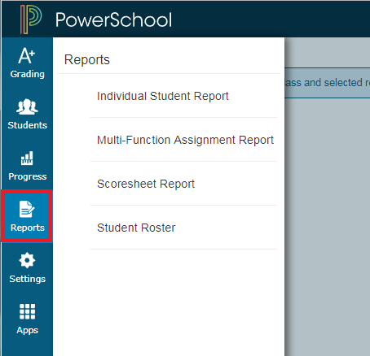
  - Student Roster Report could be used in the Substitute Teacher folder as a handy reference or printed out for a field trip.
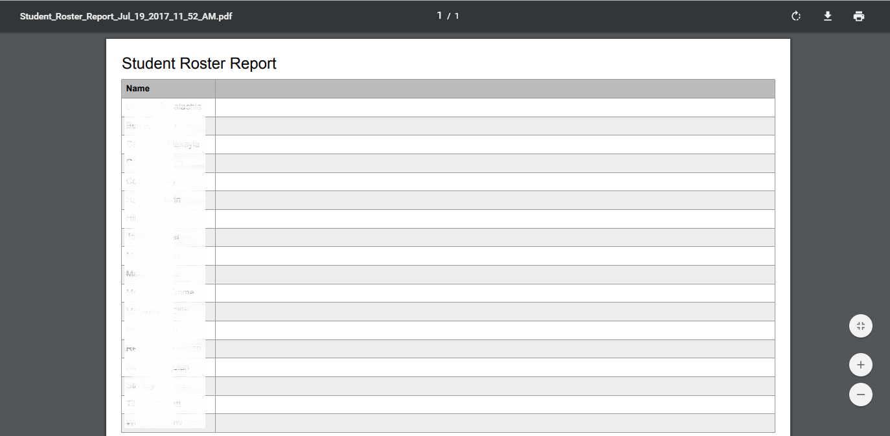

- SETTINGS – There are several personal settings to customize the PowerTeacher Pro environment.
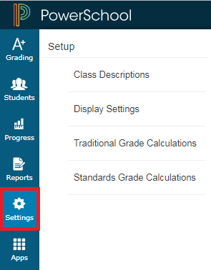
- APPS
  - The PowerTeacher Portal is available directly from PowerTeacher Pro listed with the Apps. Click on the icon and select the PowerTeacher Portal to record attendance, see backpack information and run reports.
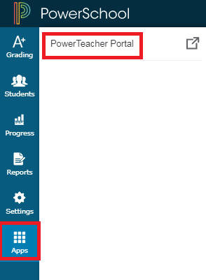
  - To run the Preschool Progress Report Card, select Reports from the Navigation menu in PowerTeacher. Then select the PK Progress Report Card from the drop-down list of available reports.
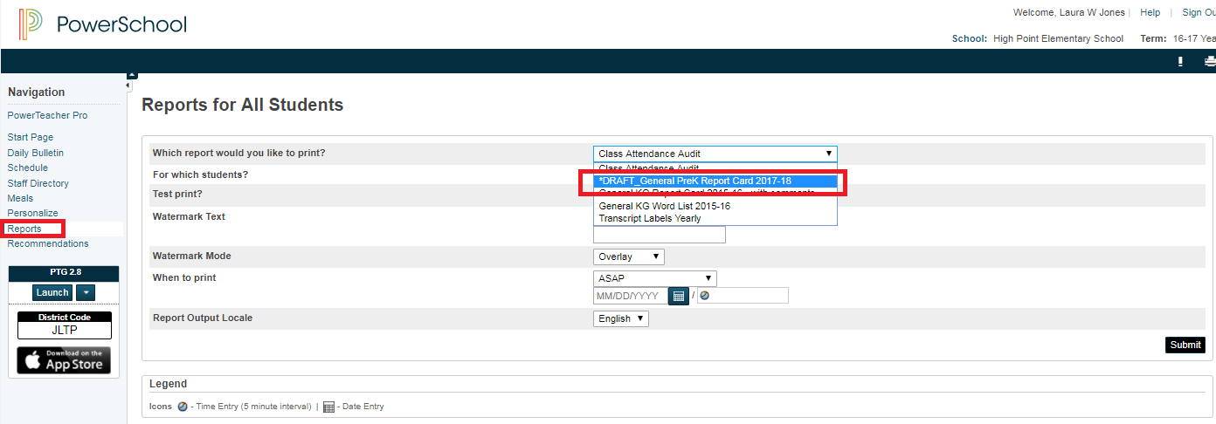
  - To see the full report, click on View next to the Job description
