|  |
| --- |
|  |



**Robotics Club**

**DRIVER’S LICENSE**

**Student Name is**

**an Official Member of the**

**Technology Department sponsored**

**Robot Driving School**

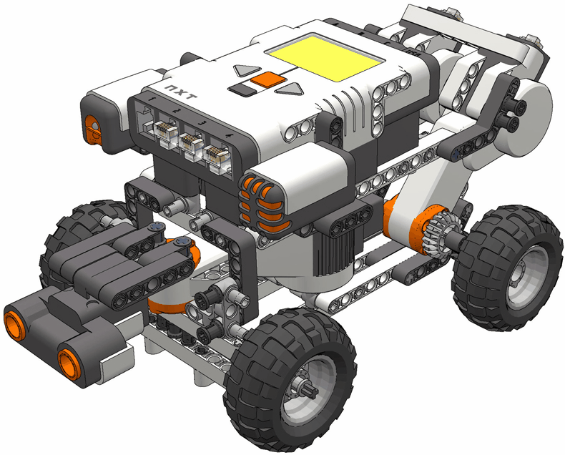

**Robotics Club**

**DRIVER’S LICENSE**

**Student Name is**

**an Official Member of the**

**Technology Department sponsored**

**Robot Driving School**



|  |
| --- |
|  |



**Robotics Club**

**DRIVER’S LICENSE**

**Student Name is**

**an Official Member of the**

**Technology Department sponsored**

**Robot Driving School**



**Robotics Club**

**DRIVER’S LICENSE**

**Student Name is**

**an Official Member of the**

**Technology Department sponsored**

**Robot Driving School**



|  |
| --- |
|  |



**WCS Robotics Club**

**DRIVER’S LICENSE**

**Student Name is**

**an Official Member of the**

**Technology Department sponsored**

**Robot Driving School**



**Robotics Club**

**DRIVER’S LICENSE**

**Student Name is**

**an Official Member of the**

**Technology Department sponsored**

**Robot Driving School**



|  |
| --- |
|  |

|  |
| --- |
|  |



**WCS Robotics Club**

**DRIVER’S LICENSE**

**Student Name is**

**an Official Member of the**

**Technology Department sponsored**

**Robot Driving School**



**Robotics Club**

**DRIVER’S LICENSE**

**Student Name is**

**an Official Member of the**

**Technology Department sponsored**

**Robot Driving School**

